Lab7: Create a Lambda in AWS to determine if a passed in number is a perfect square
Md Alamgir Hossain

Step 1: Creating the isPerfectSquare Lambda Function
1.1 Search Lambda in AWS
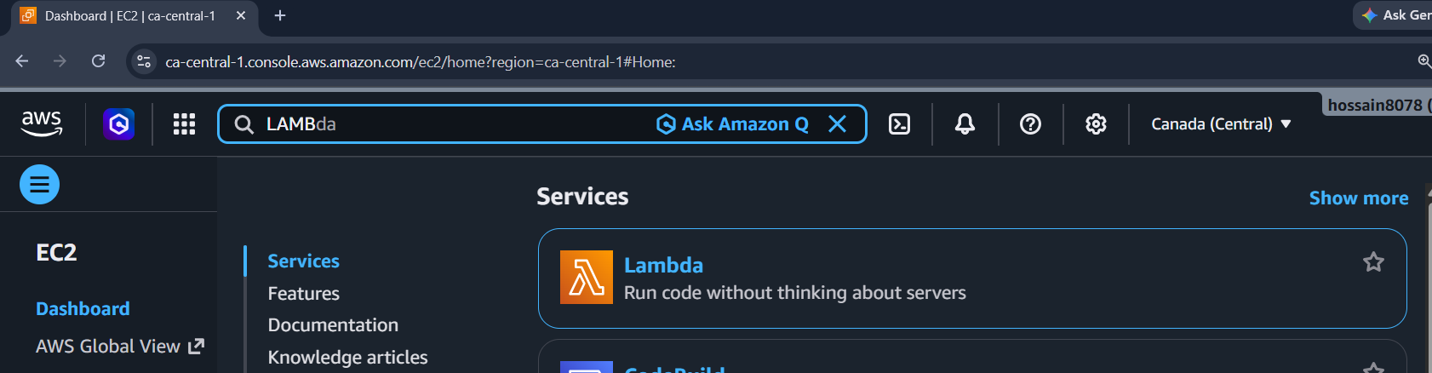
1.2 Open Lambda
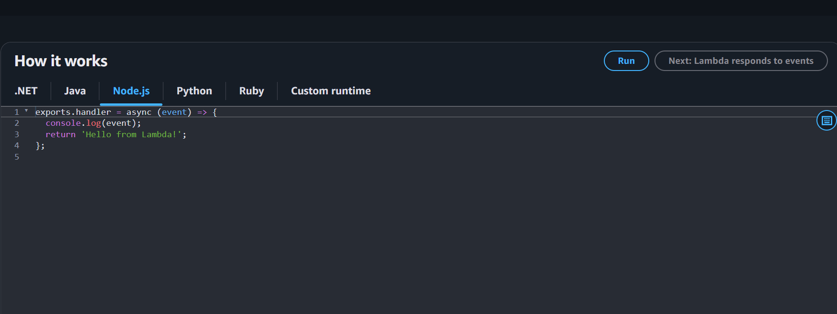

1.3 Create Lambda function named isPerfectSquure.
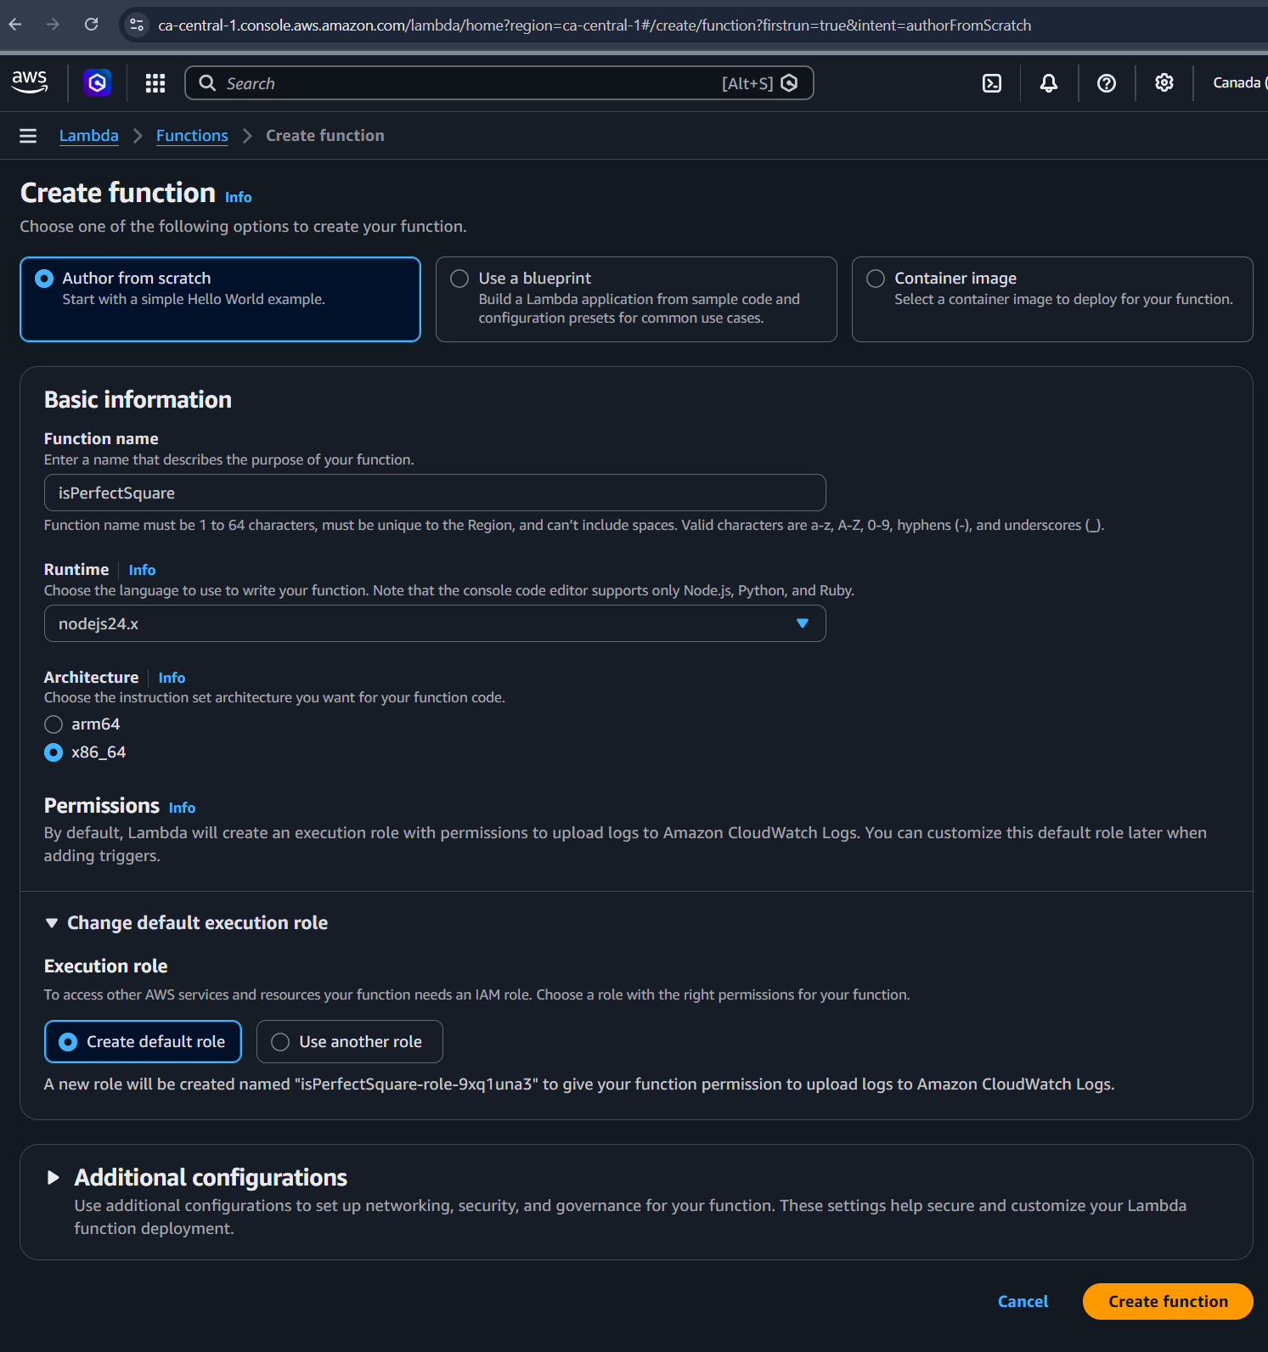

1.4 Write the Logic
In the Code source section, replace the existing code with the following logic. This code extracts the number from the URL and checks if its square root is an integer.
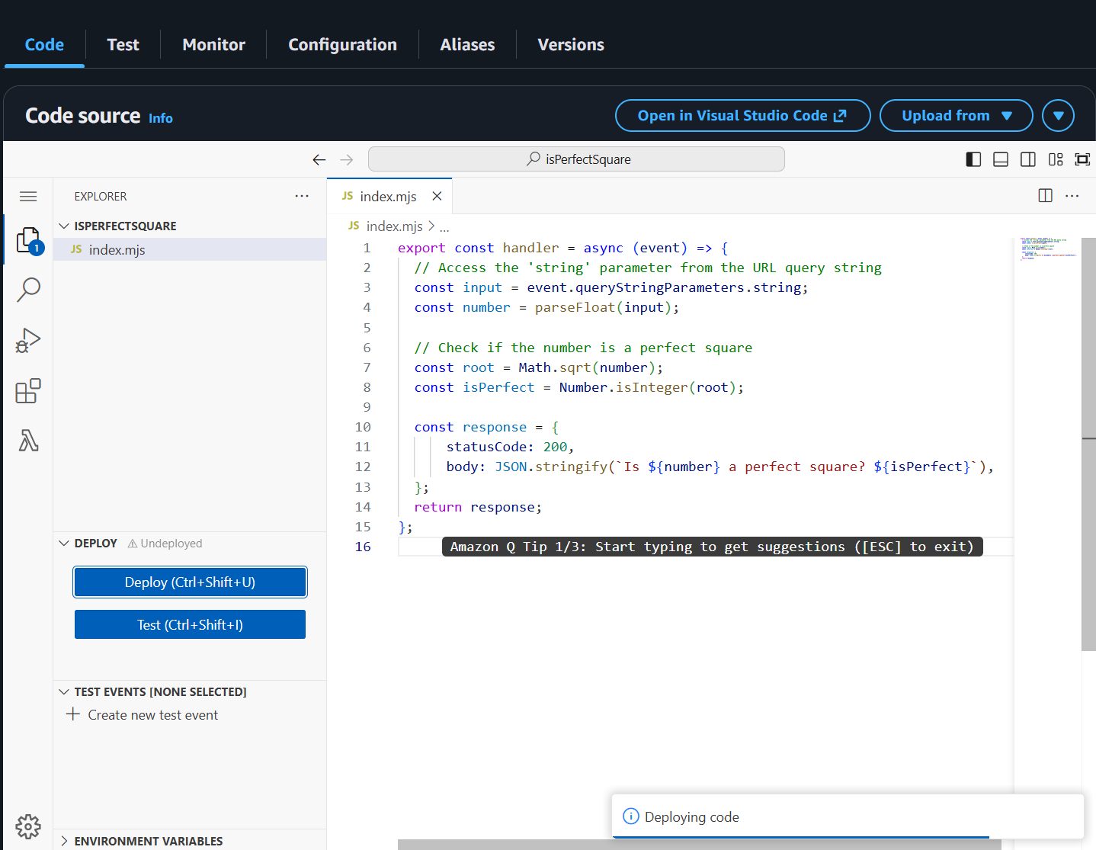

Step 2: Configure API Gateway
2.1 Add trigger.
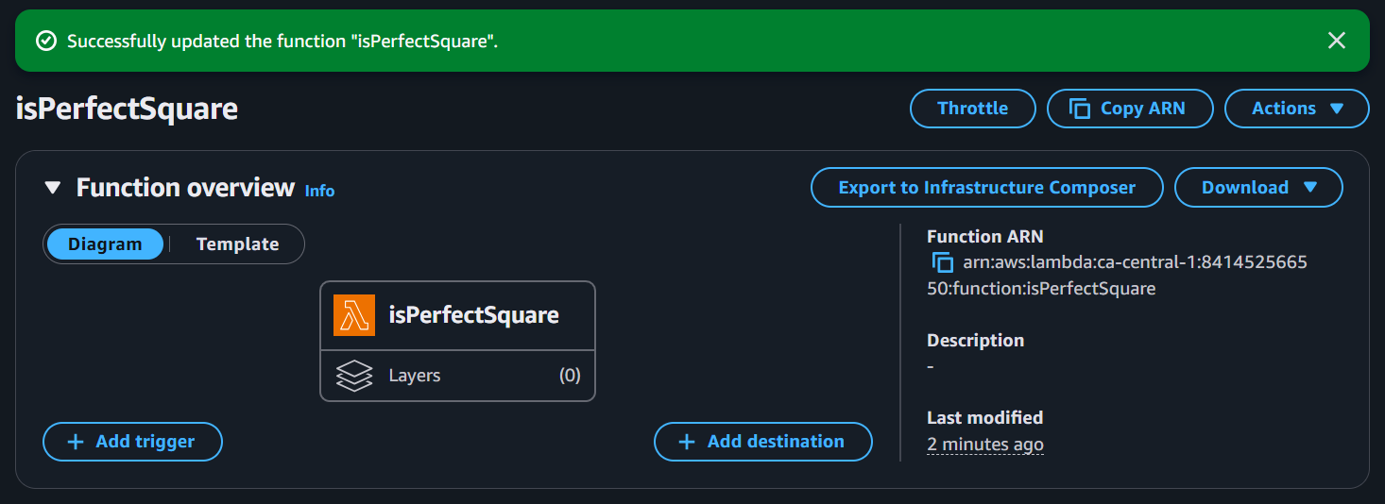

2.2 select API Gateway.
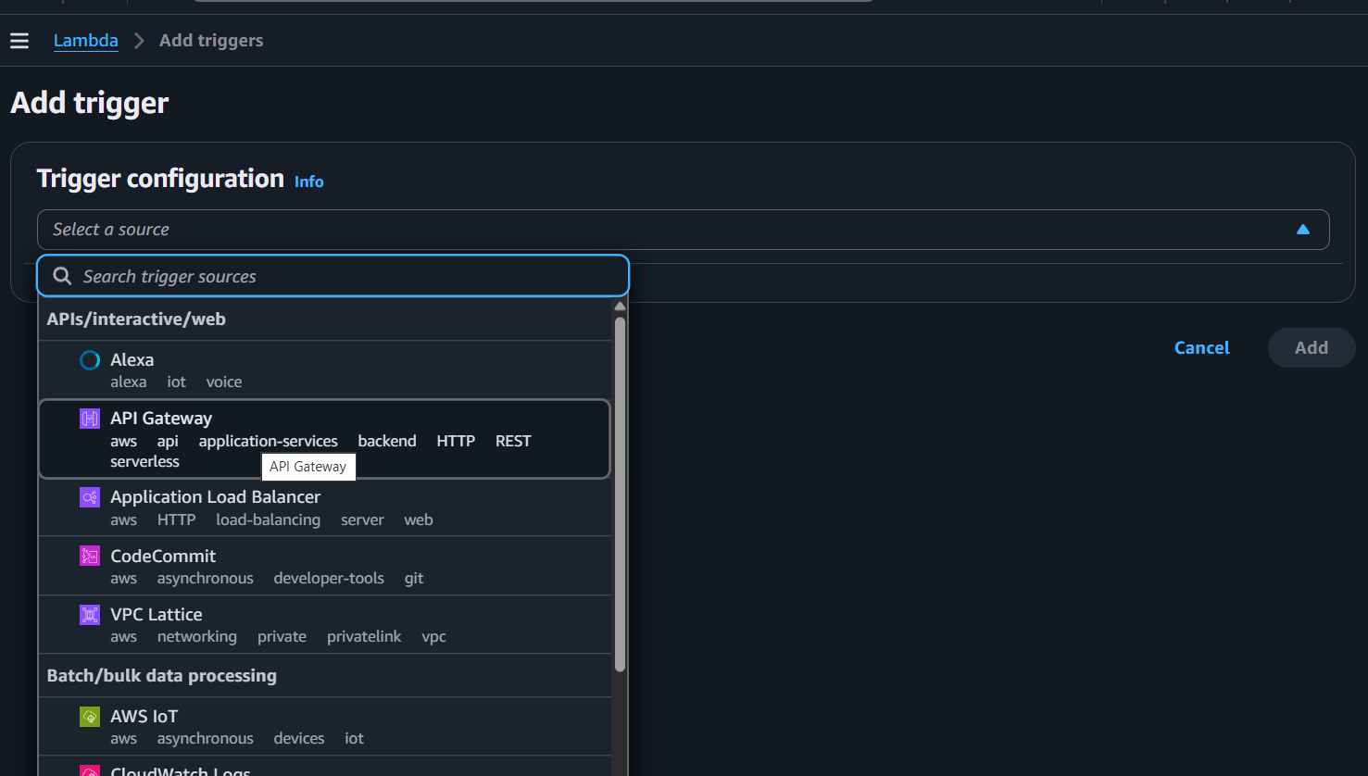

2.3 Select API Type, choose HTTP API and Cross-origin resource sharing (CORS)
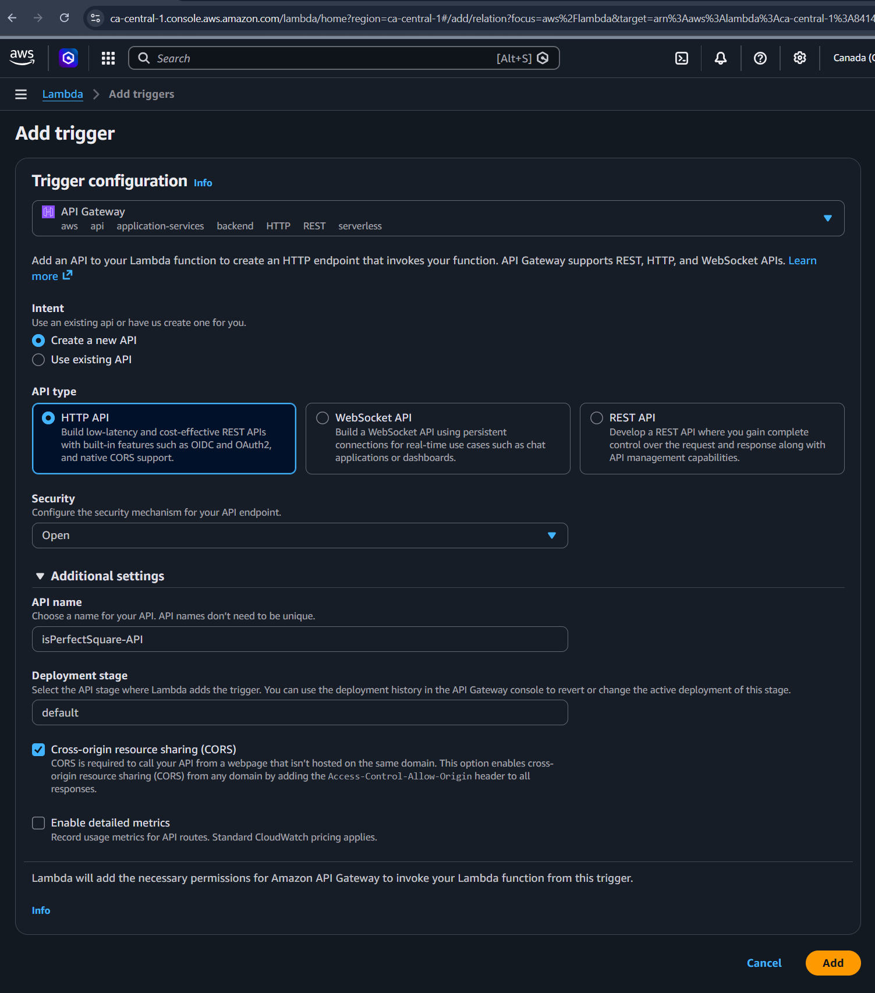

2.4 isPerfectSquare-API created.
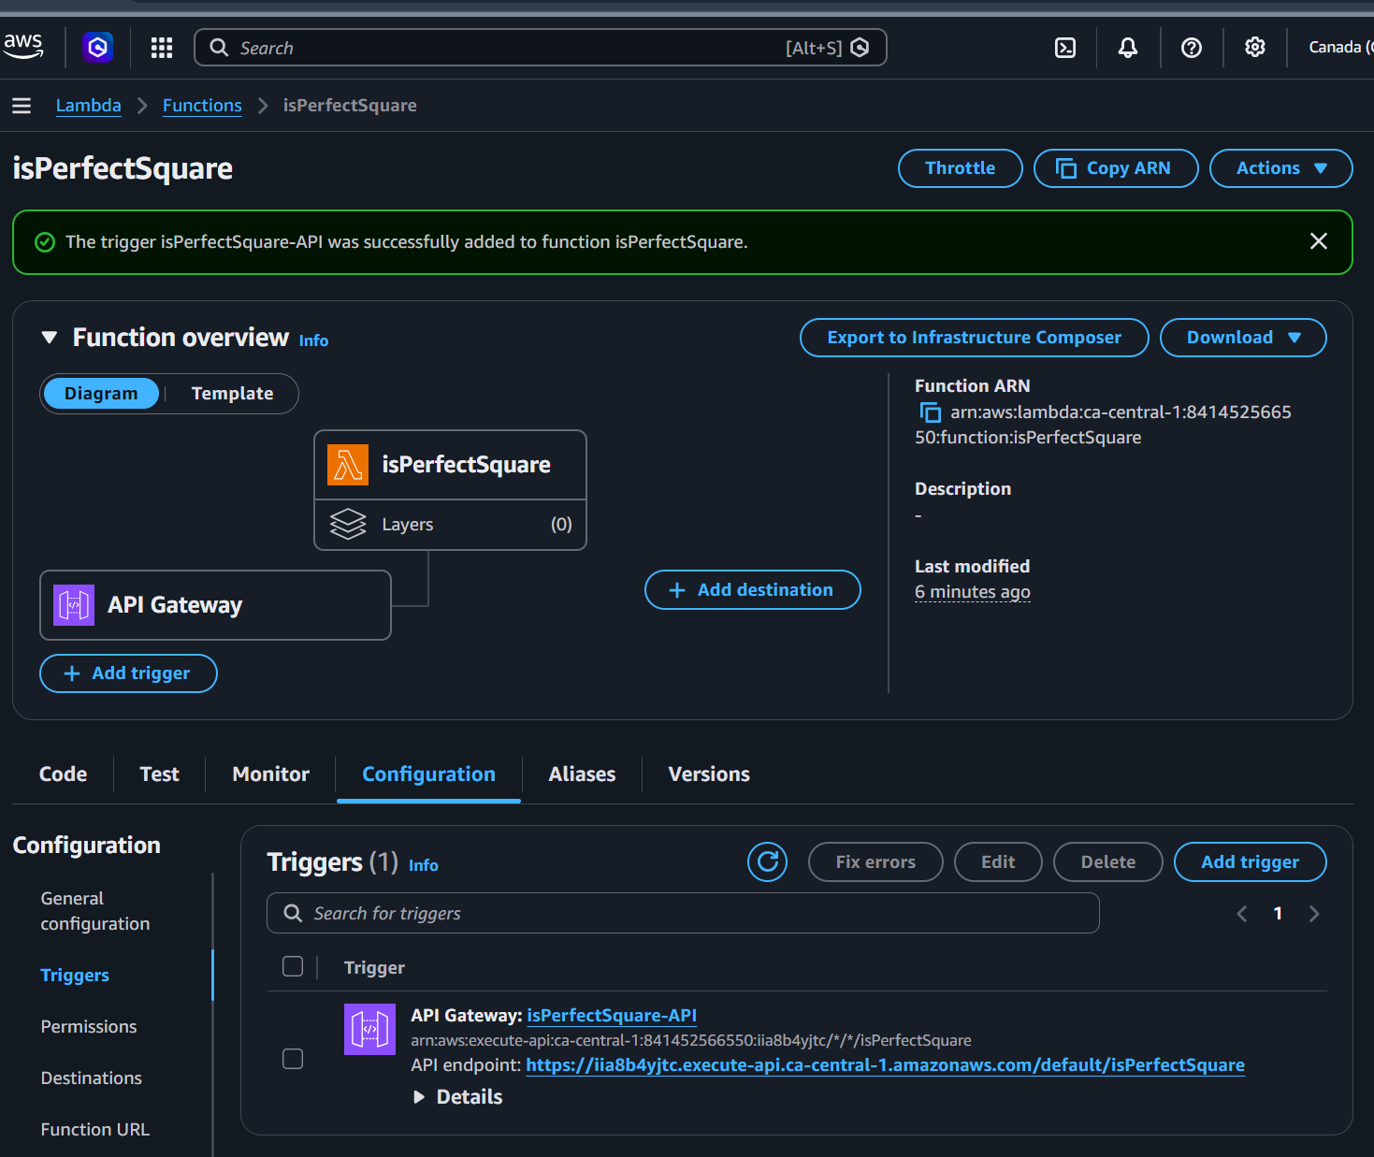

3.Prove it works
To send a string value to Lambda we take our function’s invoke URL and append to it : /isPerfectSquare?string=someValue
3.1 Value=25
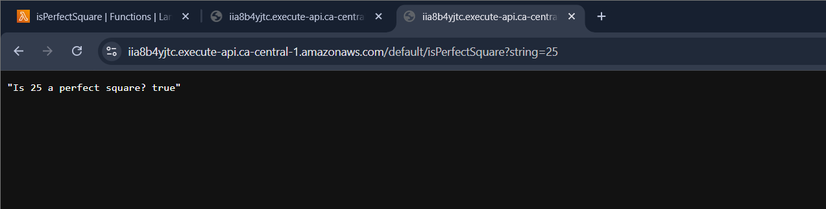
3.2 Value = 30
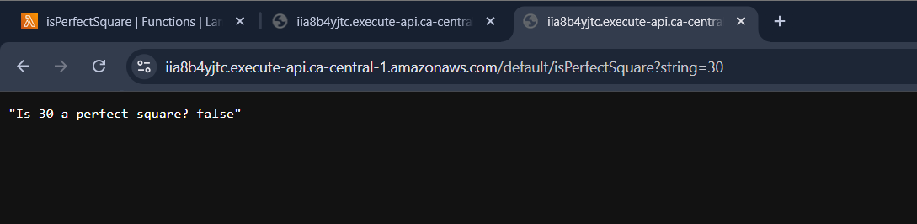
3.3 Value = someValue (string)


   

